|  |
| --- |
| **YEAR 12 Essentials Mathematics**  **Semester 2 2018**  **Test 6 – Probability** |
| Total Marks: ______ / 48 marks  Name: ______________________ Total Time: 55 minutes |

***Full working out must be shown to get full marks.***

***Attempt all questions***

***Resources allowed:***

***1 A4 page, (1 side) of hand written notes, ruler, calculator***

**Question 1 [7 marks: 3, 2, 2]**

1. Brett is going to choose a coloured chocolate at random from a pile of 50 chocolates. In the pile there are 9 green, 15 orange, 22 blue and 4 red chocolates.
2. What is the probability that Brett will choose an orange chocolate?
3. What is the probability that Brett will choose a chocolate that is not green?
4. What is the most likely colour Brett will choose?
5. When Doover plays golf he has a  chance of sinking his first putt on each hole. Doover is playing in a 36-hole competition. On approximately how many holes will Doover sink his first putt?
6. Tegan placed a bet on an online gambling site. The probability that her bet will win is . Is Tegan more likely to win or lose? Give a reason for your answer.

**Question 2 [3 marks: 1, 2]**

As of 2014, the distribution of blood types in Australia is as follows:

|  |  |  |
| --- | --- | --- |
| **Blood group** | **RhD** | **% of population** |
| O | O+ | 40 |
| O- | 9 |
| A | A+ | 31 |
| A- | 7 |
| B | B+ | 8 |
| B- | 2 |
| AB | AB+ | 2 |
| AB- | 1 |

1. What is the probability that an Australian resident will have B+ blood type?
2. Every week, Australia needs over 27 000 blood donations. How many of these blood donations could be from people with A+ blood type?

**Question 3 [5 marks: 2, 1, 2]**

The following tree diagram represents the possible outcomes of a family which has two children.

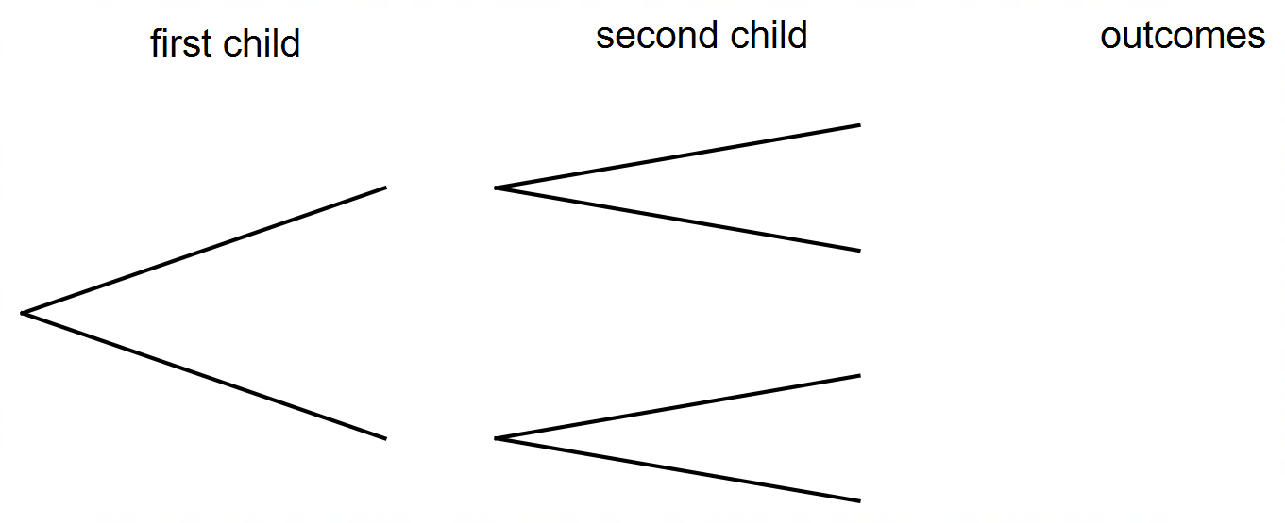

1. Label the diagram to show the possibilities of a boy and girl.
2. What is the probability the family could have two girls?
3. How could you simulate this situation and explain why chose this method?

**Question 4 [12 marks: 3, 2, 2, 2, 3]**

An agricultural research company has completed an investigation into the effect of a new fertiliser on plant growth. The heights of 30 plant seedlings grown under experimental conditions for several weeks were measured and recorded to the nearest centimetre. The heights are listed here.

|  |  |  |  |  |  |  |  |  |  |  |  |  |  |  |
| --- | --- | --- | --- | --- | --- | --- | --- | --- | --- | --- | --- | --- | --- | --- |
| 107 | 162 | 151 | 145 | 133 | 125 | 116 | 108 | 111 | 113 | 125 | 126 | 158 | 142 | 139 |
| 165 | 168 | 152 | 141 | 147 | 147 | 131 | 137 | 137 | 111 | 119 | 121 | 125 | 125 | 156 |

1. Use the data above to complete the table below:

|  |  |  |  |
| --- | --- | --- | --- |
| **Height (cm)** | **Tally** | **Frequency** | **Relative Frequency** |
| $$100-109$$ |  |  |  |
| $$110-119$$ |  |  |  |
| $$120-129$$ |  |  |  |
| $$130-139$$ |  |  |  |
| $$140-149$$ |  |  |  |
| $$150-159$$ |  |  |  |
| $$160-169$$ |  |  |  |

1. What is the probability of plants growing to a height between 120 cm and 129 cm?
2. What is the probability of plants growing to a height of at least 130 cm?
3. If the experiment is expanded to 1000 plants, how many plants would you expect to grow to a height of at least 130 cm?
4. The fertiliser is considered effective if 75% of seedlings have a height of 130 cm or more. Comment on the effectiveness of the fertiliser on plant growth, based on the results from the experiment.

**Question 5 [5 marks]**

A shop sells hot chocolate and churros. Customers can order hot chocolate or churros or both. They were particularly busy and had 250 customers last weekend.

|  |  |  |
| --- | --- | --- |
| * 83 ordered hot chocolate | * 59 ordered churros and hot chocolate | * 19 ordered no churros or hot chocolate |

1. Present this information in a two-way table.

|  |  |  |  |
| --- | --- | --- | --- |
|  |  |  |  |
|  |  |  |  |
|  |  |  |  |
|  |  |  |  |

**Question 6 [8 marks: 2, 6]**

The following tree diagram shows some of the choices available when buying a new car:



1. State the sample space of buying a new car from the tree diagram above:
2. In the tree diagram all combinations are equally likely. Given this find the probability of having
3. A Comodoor with a petrol engine and Window tint?
4. A Petrol engine?
5. A petrol engine or a Hydro Electric engine
6. A Toota and Window Tint?
7. A Toota given I had a Tow Ball?
8. Window tint given I didn’t have a Hundee?

**Question 7 [8 marks: 3, 1, 1, 1, 2]**

Spinners is a new restaurant with a randomised menu. A customer chooses each course by flicking a spinner.

Display the following information in a tree diagram.

1. Determine the probability that the meal will be Just Cabbage, Moose Knuckle and Cucumber Ice – Cream
2. Determine the probability that the meal included Poached Salmon
3. Determine the probability that the meal included Battered Bullseye and Squid Rings
4. What percentage of people had moose knuckle or salmon, and ice cream?

**End of Test**